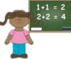
Music: During this term we shall be working on our instrument skills and using these to tell a story. 
By the end of this term children will:
- Be able to use simple untuned percussion.
- Be able to use instruments to communicate a story.
- Clap along to a beat.
Key Vocabulary: melody, beat, rhythm, instrument, appraise. perform, pulse, pitch.
DT:
This term, we will be investigating nutrition and thinking how we can design, create and evaluate our own salad. 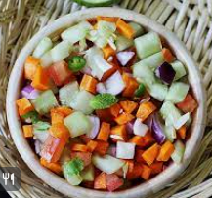
By the end of this term children will:
- Develop their understanding of different types of mechanisms.
- Be able to apply their knowledge to creating their own;
Key Vocabulary: design, location, evaluate, plan, nutrition.

Personal Social Health and Economics Education:
During this term we are exploring the idea of relationships and friendships, including how our actions affect others and how to be keep healthy, safe relationships. 
this term children will:
- Start to understand the impact they can have on others.
- Know what they can do to keep themselves safe.
Key Vocabulary: action, physical contact, bullying, safe, appropriate, kindness, responsible.
English:
Our writing this term will include pieces to both entertain and inform, such as a story and fact file. All of this will be inspired by our class book, ‘The True Story of the Three Litte Pigs’ by Jon Scieszka and the Animal Encyclopedia.
By the end of this term children will:
- Develop their writing via planning (using the boxed success criteria), drafting, editing and publishing.
- Alter their writing depending on the purpose of the piece.
- Apply taught grammar and punctuation to their writing, such as commas, full stops, capital letters and noun phrases.

Key Vocabulary: introduction, build up, dilemma, resolution, ending, heading, non-fiction. 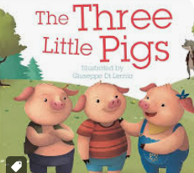
Religious Education: In R.E. we will be learning about God and Christianity, including the life journeys they go on.

By the end of this term children will: 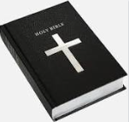
- Be able to recall the various ways in which Christians celebrate important stages of their life.
- Understand what rites of passage are.
Key Vocabulary: God, Christianity, worship, pray, praise, hymns, rites, celebrate, mark, journey.

Computing:
During our computing lessons we shall be exploring the idea of online safety and creating pictures, using Purple mash.
By the end of this term children will: 
- Be able to understand how they can stay safe online.
- Be able to use different programmes to create art.
Key Vocabulary: programmes, software, information, data.

Science: This term will be our Earth Term and we will be thinking all about plastic and our environment.
By the end of this term children will:
- Understand how they can help to reduce our plastic usage.
- Recall how companies are helping to fix the problem.
- Understand the issues involving plastics.
- Key Vocabulary: plastic, environment, pollution, ocean.

Physical Education: In PE this term we will be looking at multi-skills and dance.

By the end of this term children will:
- Be able to build up their PE skills to complete activities.
- Be able to put simple dance moves to music in order to form a routine.
Key Vocabulary: music, rhythm, roll, sprint, routine, timing, dodge, throw, catch, moves, weave.

Geography:
Over the term we shall be learning all about our world and how it differs, including factors such as animals, climate and landscapes. 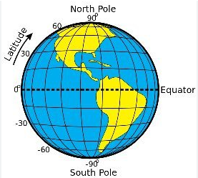
By the end of this term children will:
- Understand where the equator and poles are on the globe.
- Know the climate of the UK and how climate differs globally.
- The differences between the UK and Ecuador.
- Key Vocabulary: globe, equator, poles, climate, physical geography, human geography, capital city, adaptation, aerial photograph.

Mathematics:
In Maths this term we shall be continuing to explore addition and subtraction, learning several strategies to help us. After this, we will start to focus on shape.
By the end of this term children will:
- Be able to add and subtract 1 and 2 digit numbers from 1 and 2 digit numbers.
- Have a bank of mental and concrete strayegies to help them.
- Recognise the features of 2D and 3D shaopes.
Key Vocabulary: column method, tens, ones, addition, subtraction, sides, vertices, edges, faces.

