

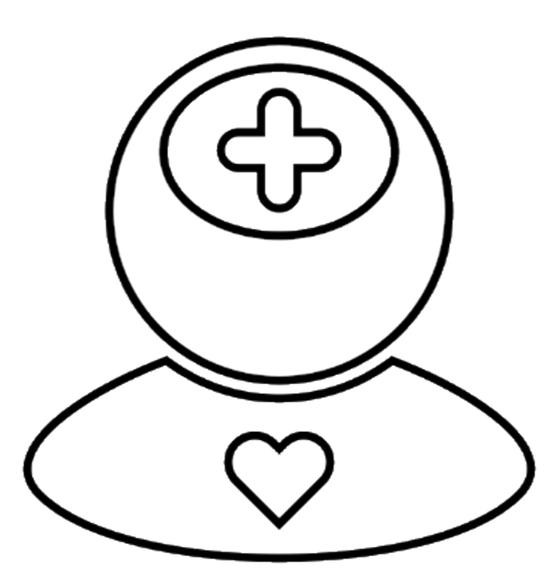
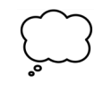
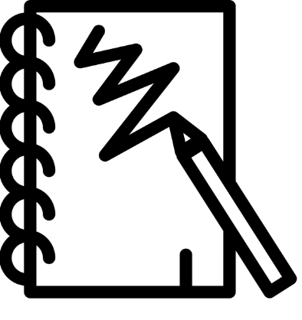
Art and Design: In art we will be planning, designing, sketching, and drawing 2D representations to 3D models. We shall be sketching from memory, from observation and then turning these creations into sculptures.

By the end of this term children will:
- Sketch and draw from memory.
- Understand how to plan and design a house.
- Design, sketch and create their own monument as a self-portrait piece.
- Develop their technique of nonprinting.

Key Vocabulary: Observe, draw, sketch, dimension, create, model.

Physical Education: In PE this term the focus will be outdoor adventure and tennis. In our outdoor adventure lessons we shall be thinking about logical reasoning and problem solving activities and working in teams.

Some of our class shall also being swimming this term. We will be developing our swimming skills by looking at floating, different strokes. Outcome will be dependent on personal swimming ability, some of you will be able to independently swim 25m.
By the end of this term children will:
- move with the ball using the correct technique in one or more invasion games with increasing speed and control, including changing direction
- pass and receive the ball using the correct technique in one or more invasion games with some control and accuracy.
- demonstrate knowledge of and begin to use some skills and techniques for attacking and defending in a game situation
Key Vocabulary: Chest, shoulder, overhead and bounce pass, pivot, attack, defense, float, front crawl, back stroke, breaststroke, butterfly.



English: In English this term, Spitfires will be using the book The Explorer by Katherine Rundell to write our own fact files, narratives and sonnets. We shall also be reading Boy In The Tower by Polly Ho-Yen.

By the end of this term children will:
- Understand and create purpose behind their writing
- Transfer key grammar and vocabulary for effect
- Understand how word choice can create effect
- Utilise inference to build narrative choices

Key Vocabulary: Fronted Adverbials, parenthesis, semi-colon, colon, informal language, authorial intent.

French: In French this term we shall apply previous skills and knowledge of topic areas such as spellings and jobs and we will have a chance to recap prior knowledge from Year 5 and you will learn the topic ‘it’s a French town’, where place names will be learnt and simple sentences and conversations.
By the end of this term children will:
- make simple sentences with habiter (to live);
- recognise key words and phrases and respond;

Key Vocabulary: Tense, simple future sentence, immediate future.

History: In history we shall learning all about the Ancient Maya, we shall be discovering for ourselves: where in the world the ancient maya were from, how the ancient maya lived, different cultures and aspects of Mayan life.

By the end of this term children will:
- Become historians and discover for themselves who the ancient maya were.
- Understand how the maya lived with their location, cultures and traditions.
Key Vocabulary: Cenote, Maya, civilization, city state, equinox, glyph, jade, Mesoamerica, stela.

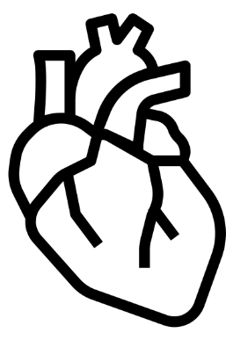
Science: In Science, children will learn about the cardiovascular system during our topic of ‘Animals Including Humans’. We shall learn about the cardiovascular system in isolation and then deepen our understanding by discovering how external factors such as diet, drugs and exercise can have an effect on it. We shall also be identifying historically how our knowledge of the prior has changed over time.
By the end of this term children will:
- Identify and name the main parts of a human circulatory system, and describe the functions of the heart, blood vessels and blood.
- Recognise the impact of diet, exercise, drugs and lifestyle on the way their bodies function.
- Describe the ways in which nutrients and water are transported within animals including humans.
Key Vocabulary: cardiovascular, heart, arteries, veins, lifestyle, exercise, diet.

Music: In music this term we are investigating the approach of DAW (Digital Audio Workstations) combined with live music. We shall be using the YuStudio in our projects to inspire creativity.
By the end of this term children will:
- Explain the differences between digital and live sounds
- Develop knowledge of how to create music in the YuStudio.

Key Vocabulary: Timbre, texture, staves, clefs, dynamics, expression, extract


Computing: Throughout our Computing lessons we shall be using the programme Purple Mash to develop algorithms that make use of basic programming.

By the end of this term children will:
- Can create subroutines/procedures/functions in their programs
- Can programmatically read and manipulate a data structure
Key Vocabulary: algorithm, coding, programming, design, procedure, function, data, application.

Personal Social Health and Economics Education: During our PSHE lessons children will be able to discuss the term ‘health and wellbeing’. Answering the question of ‘how do we keep healthy as we grow?’.

By the end of this term children will:
- Understand that there are various ways that our bodies and minds can be healthy.
- Understand that lots of different variables can affect our health in different ways.
Key Vocabulary: democracy, health, unhealthy, wellbeing, exercise, sleep, alcohol,

Mathematics: Our Maths this term will be focusing on place value up to ten million, as well as the four operations of mathematics, by securing these we shall be able to utilise our skills and apply them to more advanced calculations later in the year.

By the end of this term children will:
- Understand how we can represent numbers up to 10 million in a variety of different ways.
- Secure their knowledge on the four operations of maths.
Key Vocabulary: place value, representation, addition, subtraction, multiplication, division, reasoning, problem-solving, fluency.

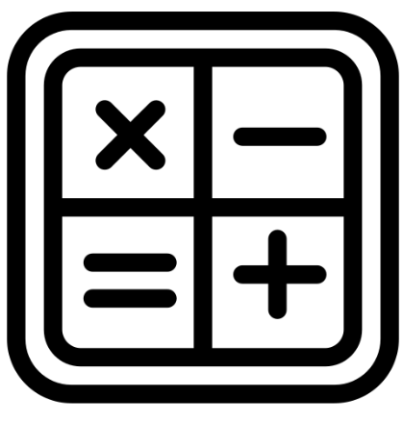
Religious Education: In RE this term, we will be developing our knowledge about - Islam and learning around the question” How does faith and belief affect the way people live their lives?” .
By the end of this term children will:
- Understand the principles of the Islamic faith.
- Understand how religion can affect peoples lives and how they live.

Key Vocabulary: The 5 pillars of Islam, The Qur’an, shariah, beliefs, faith

