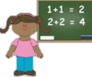
Music: During this term we shall be working on our listening, appraising and performing, through exploring call and response within animal sounds and noises. 
By the end of this term children will:
- Be able to clap along to a beat.
- Repeat simple melodies through singing.
- Perform their own version of the song.
Key Vocabulary: melody, beat, rhythm, instrument, appraise. perform, pulse, pitch.
Art:
By the end of this term children will be able to experiment with various elements of art through exploring with drawing.
By the end of this term children will: 
- Develop their understanding of how the environment can inspire art work.
- Explore the use of lines in art.
Key Vocabulary: pattern, collage, digital, continuous, senses, environment, nature, autumn.

Personal Social Health and Economics Education:
During this term we are exploring the idea of relationships and friendships, including how to maintain positive friendships and how to resolve any bumps in the road. 
this term children will:
- Start to understand what makes a positive friendship.
- Know what they can do to resolve disagreements themselves.
- Know who to talk to if they are struggling with friendships.
Key Vocabulary: resolve, friendship, relationship, positive.
English:
Our writing this term will include pieces to both entertain and inform, such as a letter and poetry. All of this will be inspired by our class book, ‘The Day the Crayons Quit’ by Drew Daywalt.
Our whole class reading will centre around the story ‘The Case of the Vanishing Granny’ by Alexander McCall Smith and will incorporate all of our VIPERS skills.
By the end of this term children will:
- Develop their writing via planning (using the boxed success criteria), drafting, editing and publishing.
- Alter their writing depending on the purpose of the piece.
- Apply taught grammar and punctuation to their writing, such as commas, full stops, capital letters and noun phrases.
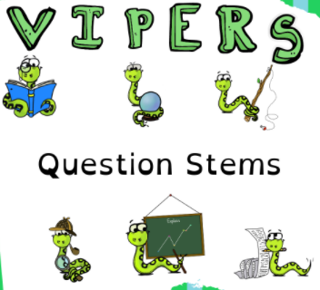
Key Vocabulary: greeting, introduction, sign off, first person, stanza, rhyme, structure, language.
Religious Education: In R.E. we will be learning about God and Christianity, including how faith and belief affect how people live their lives.

By the end of this term children will: 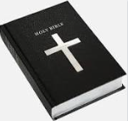
- Be able to recall what the bible says on how Christians should live their life.
- How inspirational Christians have shown their faith.
Key Vocabulary: God, faith, belief, gospel, parable, Samaritan.

Computing:
During our computing lessons we shall be exploring the idea of coding, using Purple mash.
By the end of this term children will: 
- Be able to understand what coding is.
- Be able to understand and create simple algorithms.
Key Vocabulary: coding, algorithm, instructions, data, process.

Science: Over this term we shall be exploring everyday materials and how we can organise and use them. 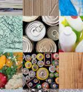
By the end of this term children will:
- Understand why we have different types of materials.
- Be able to describe the properties of different materials.
- Understand the uses of a variety of materials.
Key Vocabulary: properties, flexible, rigid, waterproof, grouping, sorting.

Physical Education: In PE this term we will be looking at the games skills of running and dodging and various other multi skills, as well as gymnastics.

By the end of this term children will:
- Confidently be able to dodge obstacles and begin to incorporate this into sports games.
- Be able to work both independently and part of a team.
- Be able to demonstrate a knowledge on how to work on low apparatus.
Key Vocabulary: co-operate, obstacle, travel, dodge movement, equipment, teamwork.

History:
Over the term we shall be learning all about transport and how it has changed over time, building on our knowledge from Year 1. 
By the end of this term children will:
- Understand what modern transport is like and why it is useful.
- Be able to recall knowledge abolut the invention of the aeroplane and cars.
- Know the significance of RAF Cranwell in the Jet| Engine’s first flight.
- Key Vocabulary: invention, modern, transport, travel, engine, motor.

Mathematics:
In Maths this term we shall be exploring place value and the value of tens and ones, including how we can represent these. After this, we will start to focus on addition and subtraction, drawing on several strategies to help us.
By the end of this term children will:
- Be able to know the worth of each digit in a 2 digit number.
- Be able to represent 2 digit numbers in a variety of ways.
- Be able to recall mental and written strategies for addition and subtraction.
Key Vocabulary: place value, worth, hundreds, tens, ones, place value chart, base ten, bead string, strategy, column method.

