Computing: During computing, children will learn about online safety and how to keep themselves and others safe whilst using the internet. They will learn what is deemed as appropriate online behaviour.
By the end of this term children will:
- To identify benefits and risks of mobile devices broadcasting the location of the user/device.
- To identify the benefits and risks of giving personal information.
- To understand what a digital footprint is.
Key Vocabulary: data analysis, location sharing, phishing, digital footprint, secure websites, screen time, spoof.

Religious Education: In RE. we are going to be building upon previous knowledge learnt about Hinduism. This includes revisiting key beliefs, recapping on Brahman and the many forms that he takes and focusing upon lifestyle choices that Hindu’s adopt.
By the end of this term children will:
- Have revisited and extended their previous knowledge about Hinduism
- Understand why Hindu’s make certain life choices and the impact that has upon others.
Key Vocabulary: Brahma and the Trimurti, karma, moksha, dharma.


Music: In music this term we will be using our scheme Charanga and be covering the unit Exploring Emotions, we shall be identifying why we like music and rhythms, what they mean to us.

By the end of this term children will:
- Learn how to listen, sing, improvise and compose pieces of music.
- Discover different genres of music.

Key Vocabulary: Timbre, texture, staves, clefs, dynamics, expression, extract

French: In French, children will learn about the shopping experience in France. They will learn how to use nuances of colour when describing colours of items and prepositional language.
By the end of this term children will:
- Take part in role play as a shopper/ shop keeper speaking in French.
- Write money amounts in French up to 500 Euros
- Answer questions using the topic vocabulary.
Key Vocabulary: À la prochaine , À demain , Bonne fin de semaine weekend]

Geography: In Geography this term we shall be discovering similarities and differences between the United Kingdom and Brazil. We shall be looking at different aspects of human and physical geography, with population, cities and man-made landmarks.
By the end of this term children will:
- Understand the similarities and differences between the UK and Brazil, through physical, human geography and culture.
- Be able to read and interpret different types of geographical maps.
Key Vocabulary: Comparison, Population density, Human geography, Physical geography, Rainforest, Urbanisation, Culture.


Science: In Science this term we are learning all about electricity. We shall consolidate our already known knowledge and then extend your learning through electrical circuits firstly learning the theory which shall be applied to a variety of practical activities.
By the end of this term children will:
- Explore circuits and their components, discussing why some circuits will work and others won’t.
- Build circuits from diagrams and draw and build our own
- Conduct an investigation to see how different wires can affect the brightness of a bulb

Key Vocabulary: electricity, wires, symbols, circuit, voltage, diagram




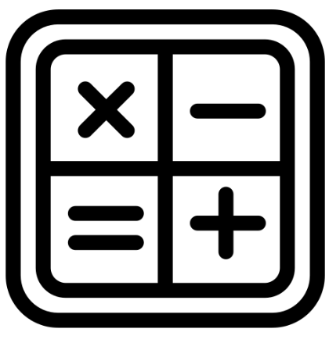
Mathematics: Our maths this term we shall be consolidating our knowledge on fractions, interpreting, reasoning and problem-solving with equivalent fractions, mixed number and improper fractions.
By the end of this term children will:
- use common factors to simplify fractions; use common multiples to express fractions in the same denomination
- add and subtract fractions with different denominators and mixed numbers, using the concept of equivalent fractions
- multiply and divide simple pairs of proper fractions
- associate a fraction with division and calculate decimal equivalent.
Key Vocabulary: place value, representation, addition, subtraction, multiplication, division, reasoning, problem-solving, fluency.

Personal Social Health and Economics Education: During our PSHE lessons children will be able to discuss the term ‘Health and Wellbeing’ in relation to our bodies health but also delving deeper into understanding Mental Health.

By the end of this term children will:
- Understand that taking care of mental health is important.
- Understand what effects different drugs and alcohol can have on the body.
- Understand we need to reflect on the media carefully.
Key Vocabulary:health, exercise, drugs, alcohol, mental health, media, trust.


Design and Technology: In D&T this term we are cooking! We are discovering different foods from around the world, where our food comes from and then creating dishes from a few different countries!

By the end of this term children will:
- Understand that the food we eat comes from all over the world.
- Understand different cuisines belonging to different countries.
- Plan, prepare and cook and taste different meals.

Key Vocabulary: cuisine, culinary, chop, prepare, mash, dice, fold, fry, peel, food miles, healthy eating, balanced diet.

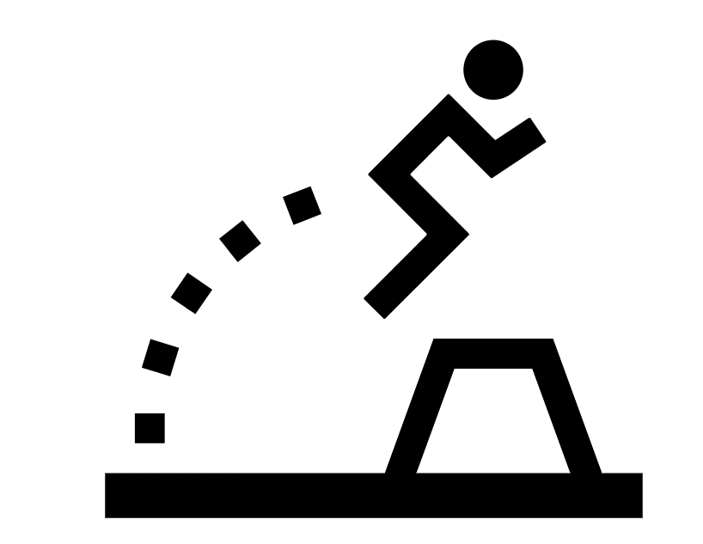
Physical Education: In P.E this term we shall be learning about different invasion games as well as gymnastics! We shall be focusing on passing, scoring and team skills for our invasion games. As well as balance, coordination and mobility for our gymnastics.

We shall also this term be developing our swimming skills by looking at floating, different strokes. Outcome will be dependent on personal swimming ability, some of you will be able to independently swim 25m.

By the end of this term children will:

- Practice hand eye-coordination
- Learn new techniques in a controlled manner

Key Vocabulary:
Opponent, interact, co-operate, repeat, demonstrate, speed, control, accuracy, front crawl, back stroke, breaststroke, butterfly, survival.

English: In English this term we are turning to the book ‘oceanarium’ for inspiration to research our own aquatic animal and create an information text on them. We shall also be looking at narrative poems this term focusing on the poem ‘Rhythm of the Rain’ by Graham Baker Smith.

By the end of this term children will:
- Understand and create purpose behind their writing
- Transfer key grammar and vocabulary for effect
- Understand how word choice can create effect
- Understand and create effective narrative poems.

Key Vocabulary: Heading, Sub-heading, bullet points, parenthesis, relative clause, subordinate clause, metaphor, simile, rhyming couplets.



