
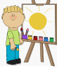
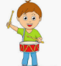
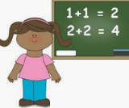
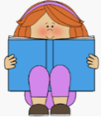
Physical Development:
We will work on our fine motor skills using fun whole body and finger work outs which will get our fingers ready for writing, drawing, and using tools!
We will learn basic movements and co-ordination skills in PE and in our outdoor area using a range of large and small equipment.
By the end of this term children will:
- Confidently and safely use a range of large and small apparatus indoors and outside, alone and in a group.
- Develop overall body-strength, balance, co-ordination and agility.
- Develop their small motor skills so that they can use a range of tools competently, safely and confidently.
Key Vocabulary:
healthy, routine, hygiene, equipment, control
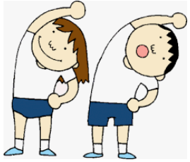
Mathematics:
In Maths we will learn counting rhymes and songs. We will match, sort and compare amounts, explore capacity, size and recreate simple patterns.
By the end of this term children will:
- Count beyond 10
- Compare numbers
- Subitise (know how many by sight)
- Count objects, actions, sounds
- Continue, copy and create patterns.
- Compare length, weight and capacity
- Key Vocabulary:
sort, match, count, more, less, size, shape, pattern, weight, capacity
Expressive Arts and Design
In expressive arts and design this term, we paint self-portraits ready for the Sturton Show! We will use different media and materials to create pictures and models. We will also learn some new songs and rhymes and talk about our favourites.
By the end of this term children will:
- Return to and build on their previous learning, refining ideas and developing their ability to represent them.
- Listen attentively, move to and talk about music, expressing their feelings and responses.
Key Vocabulary: song, chant, rhyme, soft, loud, colour, portrait, paint, easel
Personal, Social and Emotional Development:
In the first term, we will learn our new routines and expectations. We will learn what our school rules are and why it is important that we follow them. We will talk about our own thoughts and feelings and when and why we might feel that way. We will also think about keeping safe and being a good pedestrian!
By the end of this term children will:
- Increasingly follow rules, understanding why they are important.
- Remember rules without needing an adult to remind them.
- Express their feelings and consider the feelings of others.
- Think about the perspectives of others.
Key Vocabulary:
rules, feelings, happy, worry, angry, upset, kind, argue, care, considerate, pedestrian


Communication and Language
This term we will spend lots of time playing listening games and developing confidence when talking to unfamiliar people. We will use new words and develop phrases as we learn our new routines. We will discuss our favorite stories and listen carefully to new ones.
By the end of this term children will:
- Understand why listening is important.
- Use and learn new vocabulary through the day.
- Develop social phrases
- Listen carefully to rhymes and songs, paying attention to how they sound.
- Engage in story times
Key Vocabulary:
listen, favourite, rhymes, poems, opinion, discuss
Literacy
We will spend this term learning lots of new phonemes (sounds) and practise being able to recognise them and write them. We will begin to blend short words to read and work on the formation of these letters. We will learn short rhymes to help us when forming the letters.
By the end of this term children will:
- Read some individual letters
- Blend sounds into words
- Read some letter groups
- Key Vocabulary:
phoneme, grapheme, letters, sounds, handwriting
Understanding the World
Our theme this term is What is Your Superpower? so we will be learning about important real-life superheroes in History including the nurse Mary Seacole. We will also consider other people who help us and look after us. In RE, we will talk about special members of our families and our community.
- Talk about members of their immediate family and community.
- Name and describe people who are familiar to them.
- Comment on images of familiar situations in the past.
- Compare and contrast characters from stories, including figures from the past.
- Talk about members of their immediate family and community.
Key Vocabulary:
community, belonging, family, superhero, help

