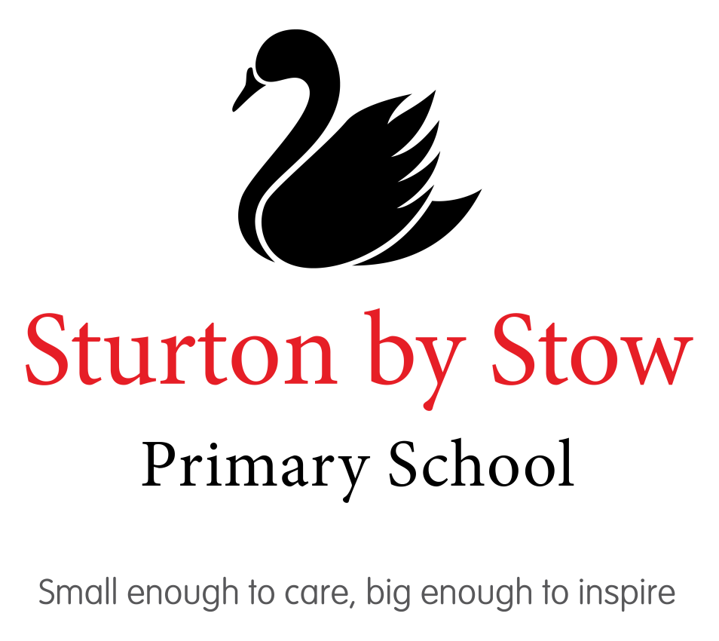

Sturton by Stow Primary School
Behaviour for Learning Policy

Contents

Section | Description | Page Number
1.0 | Aims and Scope of policy | 3
2.0 | Restorative and relational approaches:  - Restorative Enquiry  - Restorative Circles  - Restorative Mediation  - Restorative Conference | 4
3.0 | Our Code of Conduct  - Values  - Rules | 5-6
4.0 | Bullying and Cyberbullying | 6-7
5.0 | Classroom Management | 7
6.0  6.1  6.2 | Behavior Strategies  - Recognition strategies  - Support Strategies | 7-8
7.0 | Definitions | 8-13
8.0  8.1  8.2  8.3  8.4  8.5 | Roles and Responsibilities  - Headteacher  - Class Teachers  - All adults in school  - Parents and Carers  - Children | 13-15
9.0 | Monitoring | 16
10.0 | Links to other policies | 16
Appendix 1 | School Values | 17
Appendix 2 | Fundamentals of British Citizenship | 18
Appendix 3 | Rule 1 – We keep safe | 19
Appendix 4 | Rule 2 – We are ready to learn | 20
Appendix 5 | Rule 3 – We respect everything and everyone | 21
Appendix 6 | Rule 4- We be the best we can be | 22
Appendix 7 | Staff Guidance | 23-24
Appendix 8 | Statement of Relationship Principles | 25

Sturton by Stow Primary School Behaviour for Learning Policy

1.0 Aims and Expectations:
It is the primary aim of our school that every member of the school community feels valued and respected, and that each person is treated fairly and well. We are a caring community, whose values are built on mutual trust and respect for all. This policy is therefore designed to support the way in which every member of the school can work together and learn in a supportive way. It aims to fulfil our mission statement.
“Small enough to care, big enough to inspire”.

Building positive relationships is at the heart of effective behavior approaches. We have unconditional positive regards for all members of the school community, which includes Children, staff, parents, governors and members of the wider community. A strong relationship connects us to our Children and without that connection our ability to influence and lead them is diminished. Educating is the means of aiming to achieve greater knowledge and independence without impairing the rights of others. Everyone needs to feel self-respect and show respect for others. These principles are vital to the quality of our lives, learning and forming the basis of our policies.

Policy Aims
  - To provide a framework that is trauma-informed and inclusive, ensuring that it is appropriate for all children at our school
  - To create a therapeutic ethos in school whereby every member of staff responds to children’s behavior and emotions with insight and understanding based on neuroscience and trauma- informed techniques.
  - To create a nurturing, loving environment where children are not punished for having big feelings but instead are guided through them
  - To develop self-aware, empathetic and reflective thinkers whereby children are learning from their difficult feelings and behavior and developing their emotional intelligence
  - To support children through their difficult feelings and behavior with the intention of teaching and guiding them through how to manage the same feelings/ situation differently next time
  - To respond to children with connection and understanding rather than disconnection and rejection with the awareness that this will help create an opportunity to learn and for behaviors to change
  - For all children to feel safe in our care, especially when they are overwhelmed with their feelings
  - To develop positive mental health and wellbeing through this approach

Every child deserves to be inspired, have a positive mindset, recognise failure is just a steppingstone to success and to believe they can do anything they set their minds to. At SBS we aim to develop the self-awareness, self- belief and emotional intelligence of every child, regardless of their background or circumstances, to give them the tools needed to flourish in life.
Our behaviour policy for learning policy is based on scientific childhood trauma, neuroscience and child development theory as well as the therapeutic teaching approach. It takes into account all of our children and their circumstances and is particularly sensitive to the needs of our more vulnerable children whom we recognise are more likely to struggle with their behavior. This procedure aims to help children calm down, self-regulate and reflect on their feelings which in turn will then help them to manage their behavior. We recognise that all behavior is a result of a difficult feeling.

The Behavior for Learning Policy aims to promote effective learning for all by:
- Clearly stating expectations of what constitutes acceptable behavior.
- Establishing effective behavior management strategies.
- Recognising, celebrating and rewarding achievement and positive behaviour throughout the school.
- Consistently addressing conduct that does not represent acceptable behaviour through processes to enable children to reflect upon the impact of incidents and equip them for the future.
These aims are reflected throughout all the educational experiences we provide for our learners. We aim to create a happy, caring atmosphere at our school; this positive environment, we believe, fosters excellent behaviour.
We very much believe in a restorative and relational behaviour approach to maintain positive relationships and help Children to understand and take accountability for their own behaviors.

2.0 Relational and Restorative Approach
At SBS we believe the key to excellent behaviour is to build strong relationships with all of our children.
We endeavour to ensure children feel valued, respected and safe. We do this through:
- Meet and Greets – we aim to greet every child on their way into school to help start the day on a positive note
- Demonstrating to children that they are valued by noticing them as individuals, praising their efforts and remembering key information that is personal to them
- Having clear and consistent high expectations and praising behaviour that goes over and above so children know exactly what they are striving towards
- Having a clear focus on effort and achievement so all can be successful
- Making our building a safe and calm place to be by ensuring our corridors are quiet and talk is purposeful
- Starting and ending each lesson and week with time for positive reflections
Restorative approaches:
All staff will be expected to positively promote restorative approaches based on our school’s principles and values; these encourage an environment, which promotes mutual respect, the development of good relationships and the need to take responsibility for one’s own behavior. Restorative Approaches are inspired by the philosophy and practices of Restorative Justice, which puts repairing harm done to relationships and people over and above the need for assigning blame and dispensing punishment.

Key skills that the Children will develop during the restorative process include active learning, facilitating dialogue and problem solving, listening to and expressing emotion and empowering others to take ownership of problems. Restorative processes and practices include interventions when harm has happened, such as:

● Restorative enquiry
● Restorative circle
● Mediation
● Restorative conferences

There are also processes and practices that we use to help to prevent harm and conflict occurring and which we build a sense of belonging, safety and social responsibility. These include: circle time and staff modelling the values and skills and creating opportunities needed for development. This is the starting point for all restorative processes involving active non-judgmental listening. The process can be used with one person or a group to help them reflect on a situation and find ways forward for themselves. It is also useful before and during face- to- face meetings.
2.1 Restorative Enquiry
This is a key process that all staff and children will follow to support children in situations of conflict, or mediation. This consistent approach allows children to recognise that all challenges can be dealt with consistently and thoroughly. Staff will guide the children through the following 6 questions:
1. What happened?
2. What were you thinking at the time?
3. What do you think about it now?
4. Who/ how do you think has been affected by your actions?
5. What do you need to do about it?
6. How can we make sure this doesn’t happen again?
2.2 Restorative circle
This is used in challenging situations between a more and less powerful person. Skills include expressing and listening for feelings and needs and understanding why each person has acted in the way they have.
2.3 Mediation
This is useful when both X and Y believe the other person is the cause of the problem. The mediator remains impartial and helps both sides to consider the problem as a shared one that needs a joint solution. When someone acknowledges they have caused a problem to another person and both sides agree to see how the matter can be put right, with the help of an impartial mediator.
2.4 Restorative conference
This involves those who have acknowledged causing harm and meeting with those who they have caused harm to; seeking to understand each other’s perspective and coming to a mutual agreement which will repair the harm as much as possible. Sometimes all sides bring supporters, who have usually been affected and have something to say from a personal perspective

3.0 Code of Conduct

Our code of conduct instils our core values and the modelling and use of the language of choice. We publish our expectations of behaviour through our Class Charter taken from the Jigsaw scheme. A progressive scheme of work, giving Children relevant learning experiences to help them navigate their world and to develop positive relationships with themselves and others. With a strong emphasis on emotional literacy, building resilience and nurturing mental and physical health; including mindfulness allowing Children to advance their emotional awareness, concentration and focus.
We expect all children and adults to show the following values:

Always Aim High
Demonstrate Friendship and Caring behaviour
Display Tolerance to others
Value Learning
Show Responsibility
Be a Team player
See Appendix 1 - Symbols

We feel strongly that there is a need to develop both global citizenship and where possible, teach the fundamental principles of British Citizenship:
The rule of law
Individual Liberty
Tolerance and Respect
Participation in Community Life
These are prominent in our schools in a variety of ways-on displays/ in assemblies/ on the spot mention.
See Appendix 2 - Symbols
The Rules for children at our schools are:

Rules
  - All rules are communicated regularly to children
  - Rules are communicated through connective language and are aimed at building a relationship culture within the classroom/school
  - Rules are framed positively to maintain connection such as “We are ready to learn”!
  - We refrain from using the buzz words ‘no’, ‘can’t and ‘stop’ because we are aware that these words can often shut down a child causing them to respond with defense and can result in their rational brain being unable to learn from the support given

We keep Safe

We are ready to Learn

We are respectful to everyone and everything

We are the best we can be
See Appendix 3-6 – Symbols

4.0 Bullying including cyber bullying
Our schools take a proactive and restorative approach to issues between learners that might provoke conflict and we actively develop strategies to prevent bullying occurring in the first place. This often involves talking to learners about issues of difference in lessons or through dedicated events or projects. Our schools promote an ethos of good behaviour where learners treat one another and the school staff with respect because they know that this is the right way to behave. Values of respect for staff and other learners, understanding of the value of education and a clear understanding of how our actions affect others permeate the whole school environment and are reinforced by all staff and older learners who set a good example to others. (See separate Anti -Bullying Policy).
- The ‘Seven Steps Approach’:
  - The adult talks to the victim (person being bullied) about his/her feelings and what has happened
  - The adult will not question the child about the incidents but does need to know who is involved.
  - The adult arranges to meet with the pupil/group of children involved, this may include some bystanders, or even friends of the victim, who joined in but did not start the bullying. Ideally, this will be a group of 6 to 8 Children.
  - The adult tells the group about the way the victim is feeling (this is done with his/her permission) and might use a poem, a piece of writing or a drawing to help explain the victim’s distress. At no time does the adult discuss the details of the incidents.
  - The adult does not blame individuals but explains that she/he knows that the group can do something about it.
  - Each member of the group is encouraged to suggest a way in which the victim could be helped to feel happier. The adult gives some positive answers but does not mention improved behaviour.
  - The adult ends the meeting by asking the group to make sure they will help to solve the problem. A meeting is arranged to see how things are going.
  - 7. At this follow-up meeting, adults discuss with each child, including the victim (person being bullied), how things are going. This allows the adult to monitor the bullying and keep the children involved. Further meetings will be arranged if they are needed.

5.0 Classroom Management
Within our school we promote the positive behavior and self-discipline of all our learners by:
- Explicitly teaching and modelling of the high expected standard as per our school rules
- Simply expecting children to always behave well and making that explicit to them
- Maintaining high standards of teaching and learning to engage learners
- Providing opportunities to make informed choices regarding behavior, use of strategies and recognition
- Use of restorative discussion to encourage all to meet the expected standard
- Use of strategies if the expected standard is not being met
- Identifying and dealing with incidents of inappropriate behavior as soon as it is reasonably possible
- Implementing strategies to identify and reduce inappropriate behavior
- Allowing children through democratic assemblies (chatter groups) to identify school wide issues that are barriers to excellent behaviors
- External interruptions during the day being minimised.

6.0 Behaviour Strategies

6.1 Recognition Strategies:
We want to encourage and celebrate the successes of our children in a variety of different ways whilst having extremely high expectations for behaviour. The following recognitions have been decided in consultation with children and staff in our school.

    - Acknowledging good behaviour through gestures such as smiles and thumbs up
    - Verbal rewards, making explicit what the child has done well e.g. ‘well done, that was going over and above just then when you____’
    - Postcards, letters, phone calls or emails home
    - Recognition in assemblies and recognition boards in classrooms
    - Sharing work with the class, another class, a member of staff or Headteacher
    - Class Dojo Points to recognise when children demonstrate our Values
    - Team point prize afternoon – For team with the most tokens
    - Hot Chocolate / Ice Lolly Friday with the Headteacher

We use the online recognition system, Class Dojo. Children receive dojo points alongside other forms of recognition, for showing behaviours in line with our code of conduct in school and indeed going over and above, the points are linked to our values. A class might receive a whole class recognition if the collective total of points reaches a certain amount (at the discretion of the adults in class). Each desirable behaviour is worth a maximum of 1 point to ensure consistency across school. We use dojo points as a positive reinforcement tool only and do not take dojos away.
Dojo points will be tracked and totals for the four houses (Willow, Maple, Oak and Horse Chestnut) will be shared with each class. The winning team will receive a cup with their house-coloured ribbon which will be presented weekly. A prize afternoon at the end of each long term will be awarded to the House with the most dojos
Feel Good Friday
Feel Good Friday takes place for 20 minutes at the ed of the school day on a Friday afternoon (3:00 – 3:20pm) during which time staff will offer a range of activities chosen in conjunction with the children. Every child is entitled to this wellbeing time as we feel it is chance for the class to spend quality time with their teacher, build relationships and end the week on a positive note. The activities provided are linked to the NHS 5 Steps to Wellbeing which are:
- Connect with other people
- Be physically active
- Learn new skills
- Give to others
- Pay attention to the present moment (mindfulness)

The class target for next week / term will be set at the end of this time, which is to be displayed in the classroom with a relevant symbol to remind everyone.

A reminder will be given at the start of each week by the class teacher and referred to throughout the week.

6.2 Support Strategies
Strategies are used to encourage learners to recognise and make appropriate adjustments with regard to their behaviour. These include:

- Removal of a learner who engages in disruptive behaviour in the classroom, refusing to follow reasonable instructions, or who is frequently off task, to a place away from the rest of the class.
- Reminder, warning, conversation at appropriate time.
- Children learning to apologise and recognise the impact on others of poor behaviour.
- Loss of playtime, at either break or lunch times, when the learner must be in an area supervised by a member of staff because of continued undesirable or extreme behaviour.
- Loss of privilege.
- Parental/Carer involvement to support choice making.
- Opportunities for discussion between the injured parties.
- Seclusion to an area of school where self-reflection can take place.
- Any unfinished work to be taken home.
- In extreme and prolonged cases of challenging behaviors fixed term exclusion- the safety of the child, their peers and adults in school is the main focus here.
- Permanent exclusion is the final step.
7.0 Definitions

7.1 Undesirable Behaviour
Although we focus on positive behaviour and recognition, we understand that sometimes children may display behaviours which are detrimental to learning. If children display behaviour deemed inappropriate, we take the approach which we feel best fits the situation. A verbal warning and a reminder of how to behave may suffice. However, sometimes there may need to be an different strategy to be used. The approach used is at the discretion of those involved and it will depend on the severity/nature of the incident and the age/maturity of the child. Children may be asked to participate in regulation time. Regulation time allows ‘Thinking Time’, after which there will be opportunity to discuss the behaviour and to address the causes. The Thinking Time provides time and space to reflect and calm down for all involved and consider restorative measures.
We understand that it can be difficult to make time to discuss incidents during or immediately after the occurrence, but we also understand that taking this time to repair relationships will prove invaluable in the future. We strive to take time to discuss wrongdoing with all parties so that the right choices will be made later. Discussions about behaviour are a quick but thorough way of discussing harm and repairing it.

We will aim to use common language across school when we address behaviour incidents and encourage children to be reflective as seen below in our connection and co-regulation procedure. We appreciate the importance of ‘thinking questions’ (avoiding ‘why’ which doesn’t encourage reflection) so the child/children involved understand what has happened and how we might move forward.

The ‘solution’ might be an apology, a sorry letter, further regulation time or time to repair the harm done (e.g., tidying any mess caused). This is at the discretion of the parties involved and all should agree with the outcome.

We understand that one approach does not work for all children. Our policy will be adapted accordingly, and reasonable adjustments will be made including an individualised plan if necessary.
Step One: Therapeutic Approach
Staff will respond to a child’ difficult feeling or behaviour incident calmly using a therapeutic response. They will follow the steps below and help the child to understand how they are feeling. This will help the child feel understood, valued and heard. We acknowledge that although he child may have made a mistake or done something wrong, we are conscious that there will have been a trigger to make this happen and this this is often an overwhelming feeling that a child may struggle to identify. We need to help children to recognise and understand this before we focus on the behaviour incident.
Step Two: Boundary
In response to challenging behaviour, we will put a boundary in place. This will either be in the form of a responsibility, whereby we ask the child to make amends for what they have done by picking up wha they have thrown or broken and fixing it for example helping to put things right. Or a limitation boundary where something gets taken away, such as iPad time or football. We are aware that a child will need some regulation time (Step 3) before they can fulfil the responsibly, we have asked them to do.
Step Three: Regulation Time
We are aware that when children show challenging behaviour, they are often experiencing overwhelming feelings. At SBS we want to teach our children how to regulate and manage big emotions. We may ask children to have regulation time to help them to do this. Children will be able to listen to calming music, do some quiet reading or colouring or whatever they need to help regulate and manage their emotions. We acknowledge that children need to be regulated before they can learn how to change their behaviour and be able to learn to react differently next time.
In the event of a child who is extremely overwhelmed, being physical or verbally abusive towards other will be supported to regulate through regulation strategies. This is not time out or a consequence. Regulation time is where a member of staff will sit with or near the child and support them to regulate
Children will be expected to sit with a member of staff until and regulate. This might be done by counting together. The member of staff stays with the child throughout this process to help them regulate their emotions. This is not a punishment or consequence where we reject the child and send them away, instead we sit with them, reassure them and help them to manage the very overwhelming feelings they are experiencing. Children will be expected to sit with the member of staff until they feel they have regulated without further physical or verbal retorts or moving away. This is not a confrontation method and will respect the child is already angry or frustrated., When the child has calmed down, they will be offered further regulation time before being asked to make amends for their behaviour through a limitation responsibility (as mentioned in Step 2)
Step Four: Consistency
This approach will be followed by every adult in our school and appropriate training will be given. Children at SBS deserve to feel safe and secure, especially when they find a situation or feeling hard for them in school. We aim to ensure that this approach is consistent to communicate that we are here to support them both academically emotionally. This is part of the social, emotional and regulation development and will help to develop a positive approach to mental health and wellbeing as well as taking accountability for their actions.
Therapeutic Classroom
In some cases of exceptionally challenging behaviour, we will provide internal calm-space for our children. This will provide them with an opportunity to regulate and reflect on their emotions within school but away from the rest of their class. This is not a form of rejection but rather an acknowledgment that they are struggling more than usual and need more help to regulate. Out therapist classroom will provide them opportunities to reflect on their behaviour and focus on regulation.
7.2 Misbehaviour is defined as:
- Not adhering to the school rules
- Disruption in lessons, disruption in corridors between lessons, and at break and lunchtimes
- Not listening to adults
- Non-completion of classwork
- Not showing our school values
  - Serious misbehaviour is defined as:
- Repeated breaches of the school rules and or values
- Any form of bullying
- Sexual violence, such as rape, assault by penetration, or sexual assault (intentional sexual touching without consent)
- Sexual harassment, meaning unwanted conduct of a sexual nature, such as:
- Sexual comments
- Sexual jokes or taunting
- Physical behaviour such as interfering with clothes
- Online sexual harassment, such as unwanted sexual comments and messages (including on social media), sharing of nude or semi-nude images and/or videos (including pseudo-images, which are computer-generated images that otherwise appear to be a photograph or video), or sharing of unwanted explicit content
- Vandalism
- Theft
- Fighting
- Racist, sexist, homophobic or discriminatory behaviour

Behavior Outside School
As a school we will reinforce and praise good behaviour that occurs off the school premises which is witnessed by a staff member or reported to the school. This may include, for example, acknowledgement in whole-school assemblies, class discussion or award of a certificate or team points. Parents are encouraged to communicate such incidents to their child’s class teacher.
There is an expectation that parents are responsible for guiding and monitoring their children’s behaviour outside school. However, school will respond to negative behaviour occurring off the premises which is witnessed by a staff member or reported to the school and respond proportionately and fairly according to the age of the learners, and any other special circumstances that affect the pupil.
Staff can discipline learners for inappropriate behaviour outside school including online behaviour when the pupil is:
- taking part in any school-organised or school-related activity
- travelling to or from our schools
Staff may take action learners for inappropriate behaviour outside school whether or not the above applies, if the behaviour:
- could have repercussions for the orderly running of the school
- poses a serious threat to another pupil or member of the public
- could adversely affect the reputation of the school.

In all cases of misbehavior, the teacher can only take action against the pupil on school premises or elsewhere when the pupil is under the lawful control of the staff member.

Additional support
We recognise that a variety of situations can result in learners finding it difficult to manage their behavior. When this occurs, the teacher will meet with parents/carers to establish a working relationship to share observations and decide how to support the learner. A program of support will be planned to enable the learner to make appropriate choices about how they behave. Children may also be asked which is their trusted adult/s in school they can relate to a significant other for when a crisis point is reached- if possible, this will be put into place.

A referral to outside agencies, for example an educational psychologist, for assessment or specialist support may be deemed necessary for learners who display continuous inappropriate behaviour. This is always discussed with parents, and parental permission is always obtained prior to such referrals.

Please refer to our SEMH policy for further guidance.
Transition - support for our Children
The school will support incoming Children to meet behavior standards by offering an induction process to familiarise them with the relationships and restorative policy and the wider school culture.
Preparing outgoing Children for transition
To ensure a smooth transition to the next year, children have transition sessions with their new teacher(s). In addition, staff members hold transition meetings.
To ensure behavior is continually monitored and the right support is in place, information relating to pupil behaviour issues may be transferred to relevant staff at the start of the term or
year.
Statutory and Legislative Guidance

This policy is based on advice from the Department for Education (DfE) on:
- Behaviour and discipline in schools
- The Equality Act 2010
- Use of reasonable force in schools
- Supporting Children with medical conditions at school

It is also based on the special educational needs and disability (SEND) code of practice.

Positive Handling and Intervention

School staff have a legal power to use force to control or restrain (never to punish) and lawful use of the power will provide a defense to any related criminal prosecution or other legal action.

The term ‘reasonable force’ covers the broad range of actions used by most teachers at some point in their career that involve a degree of physical contact with learners.

Force is usually used to either control or restrain. This can range from guiding a pupil to safety by the arm to more extreme circumstances such as breaking up a fight or where a student needs to be restrained to prevent violence or injury.
‘Reasonable in the circumstances’ means using no more force than is needed
Please refer to ‘Use of Reasonable Force – Advice for Head teachers, Staff and Governing Bodies DFE-00060-
2011, July 2011’.

https://www.gov.uk/government/publications/use-of-reasonable-force-in-schools
April 2026

Suspensions and Exclusions
We do not wish to exclude any learner from school, but sometimes this may be necessary. Any exclusion will be operated in accordance with Section 52 of the Education Act 2002 under the statutory guidance for Exclusion from Maintained Schools, Academies and Pupil Referral Units in England (2012).
If children become unmanageable by refusing to follow instructions which can prevent others from learning
or place others at harm’s risk, damage school property persistently this could be an option.
The Headteacher may exclude a child for one or more fixed periods, for up to 45 school days in any one school year.
In extreme and exceptional circumstances, the Head Teacher may exclude a child permanently.
It is also possible for the Head Teacher to convert a fixed-term exclusion into a permanent exclusion, if the circumstances warrant this and procedure has been followed.
Only the Head Teacher has the power to authorise a permanent exclusion for a child from school.

In the case of a suspension or exclusion, if the Headteacher cannot be contacted or is not on site then the most senior person on site is able to make a decision in line with this policy and the legal framework informing the Headteacher as soon as is possible. This is known as delegation of powers.
If the Head Teacher excludes a child, s/he informs the parents or carers immediately, giving reasons for the exclusion / suspension. At the same time, the Head teacher makes it clear to the parents or carers that they can, if they wish, appeal against the decision to the governing body. The school informs the parents or carers how to make such appeal. The Head Teacher informs the LA and the governing body about any permanent exclusion, and about any temporary suspensions beyond five days in any one term. The governing body itself cannot either exclude a child or extend the exclusion period made by the Head Teacher. The governing body has a discipline committee. If the governors' appeals panel decides that a child should be reinstated, the Executive Headteacher must comply with this ruling.

When a child is suspended or excluded the following procedure will be carried out
- The legal framework will be followed at all times
- The child will be brought to the school welcome area by the offices
- They will be always treated with respect
- They will be supported by an adult
- They will be offered a calm safe space and a drink
- The Executive Headteacher or Senior Leader on site will contact the parent/carer and explain the exclusion
- The child will wait for collection in a calm environment and away from peers and others children
- The exclusion will be explained to the pupil
- The child’s belongings will be collected by an adult from the classroom area

The school acknowledges that corporal punishment is illegal in any form.

Confiscation of Inappropriate Items
The following items are not allowed in our schools:
  - Knives and weapons
  - Alcohol
  - Illegal drugs
  - Stolen items
  - Tobacco, cigarette papers and vapes
  - Pornographic images
  - Any articles that have been or are likely to be used to commit an offence, cause personal injury or damage to property

Other items must be passed on to the Head Teacher who will decide if and when to return an item, or whether to dispose of it. The Head Teacher will always inform parents of confiscated items from the list above.

Allegations of Abuse against Staff
Malicious accusations made by children or adult against staff will be dealt with in accordance with the advice in ‘Dealing with Allegations of Abuse against Staff’ (DfES, Oct 2012). Staff will not automatically be suspended pending investigation.

8.0 Roles

8.1 The role of the Headteacher

It is the responsibility of the Headteacher, under the School Standards and Framework Act 1998, to implement the school behaviour policy consistently throughout the school, and to report to governors, when requested, on the effectiveness of the policy. It is also the responsibility of the Headteacher to ensure the health, safety and welfare of all children in the school.

The Headteacher supports the staff by implementing the policy, by setting the standards of behaviour, and by supporting staff in the implementation of the policy.

The Headteacher has records of all reported serious incidents of misbehaviour.

The Headteacher has the responsibility for giving suspensions and exclusions to individual children for serious acts of misbehaviour. For repeated or serious acts of disruptive and anti-social behaviour, the Headteacher may permanently exclude a child (See policy)

8.2 The role of the Class Teacher

It is the responsibility of the class teacher to ensure that Values are upheld in their class, and that their class always behaves in a responsible manner around school. It is the responsibility of all staff to ensure children are behaving in a safe and respectful manner around school and children should be frequently reminded of our Values and recognised for their good behaviour.

The class teachers in our school have high expectations of the children in terms of behaviour, and they strive to ensure that all children work to the best of their ability and will model and praise our school Values to reinforce this.

The class teacher treats each child fairly and enforces the classroom code consistently. The teacher treats all children in their class with respect and understanding. However, class teachers appreciate that a sanction that works with one child may not work for all children. This is why we believe in building excellent relationships with all Children.

We aim to ensure that children feel listened to and valued – we focus on repairing the harm and making things right. We want children to feel that we are working together to solve the problem and we appreciate that each incident is different and that there may be a variety of underlying reasons for the undesirable behaviour.

The class teacher liaises with external agencies, as necessary, to support and guide the progress of each child.

The class teacher reports to parents about the progress of each child in their class, in line with the whole–school policy. The class teacher may also contact a parent if there are concerns about the behaviour or welfare of a child.

8.3 All Adults in School:
We recognise the role of teaching, support staff and parents, in setting an example and encouraging good standards of conduct, developing social and personal skills.
All of the adults in our whole school communities are ready to listen sympathetically to parents’/carers and children’s worries and concerns. In some circumstance children will be allocated a key person with whom a strong relationship can be built to support their needs. The voice of the child will be important in this choice. Teachers, teaching assistants and other paid staff with responsibility for learners have the power to discipline learners whose behaviour is unacceptable, who break the school rules or who fail to follow reasonable instructions.
Teachers, teaching assistants and other paid staff with responsibility for learners can set reasonable strategies in response to poor behaviour.
These strategies will be a reminder, a warning followed by a conversation with a member of staff when most appropriate.
To ensure the success of this policy we seek to build a partnership between school and parents/carers. The schools collaborate actively with parents/carers, so that learners receive consistent messages about how to behave at home and at school. Our Home/School Agreement outlines the responsibilities of the parent/carer and the school; including those around behaviour.

8.4 The role of governors
The governing body has the responsibility of setting down these general guidelines on standards of discipline and behaviour, and of reviewing their effectiveness. The governors support the headteacher in carrying out these guidelines.

The Headteacher has the day-to-day authority to implement the school behaviour for learning policy, but governors may give advice to the headteacher about disciplinary issues. The Headteacher must take this into account when making decisions about matters of behaviour.

We have a specific governor who is nominated as the link governor for behaviour.

8.5 Parents and Carers
We will be aspirational to all our families and expect all our parents and carers to work in partnership with our school to support their children by:

● Sharing important/ pertinent family information
● Encouraging children to attend school regularly
● Engaging with the school’s timetable of events and communicating regularly and
effectively with the staff team to ensure that the school can respond appropriately to
support the whole family
● Talking to the school staff about the challenges they face and action the support they
need from the school or other agencies
● Support the staff and school in achieving aspirational targets.
● Get to know the school’s Behaviours for Learning policy and reinforce it at home
where appropriate
● Support their child in adhering to the schools to the Behaviours for Learning policy
● Inform the school of any changes in circumstances that may affect their child’s
behaviour
● Discuss any behavioural concerns with the class teacher promptly
● Take part in any pastoral work following misbehaviour (for example, attending reviews of
specific behaviour interventions)
● Raise any concerns about the management of behaviour with the school directly, while
continuing to work in partnership with the school
● Take part in the life of the school and its culture

Positive relationships within the school are based on making expectations clear to the children, being fair and consistent, listening to each other and addressing any issues as they arise. All staff have a contribution to make in this area.

Matters of attitude and behaviour are not somebody’s concern; they are everybody’s business.

8.6 All Children in School:

All children are expected to behave in a way, which is respectful to other people and the school
environment. There are a brief set of rules which are made known to the children when they come to the school and to which they should follow via the Home School Agreement. A consistent approach to establishing these rules should be adopted by all staff and children:

We keep Safe

We are ready to Learn

We are Respectful to Everyone and Everything

We Be the Best we can Be

Our Behaviours for Learning, SEMH, SEND Anti-bullying policy ensures flexible consistency across school to meet the needs of individual Children. Behaviour is carefully monitored and we will contact parents at an early stage if we feel that a child’s actions are outside the range of expected behaviours or are a cause for concern. Working closely with our parents is of utmost importance to us.

9.0. Monitoring arrangements
This policy will be reviewed and approved by the Head Teacher and full governing board of Sturton By Stow Primary School every year.

The written statement of expected principles (appendix 8) will be reviewed and approved by the full Governing Board of on an annual basis

10.0. Links with other policies

This behaviour policy is linked to the following policies:
- Exclusions policy
- SEND policy
- Child Protection and Safeguarding policy
- Anti-bullying policy
- Acceptable Use Policy
- AI Policy
- Attendance policy
- On-line Safety policy
- Equality and Inclusion policy
- SEMH Policy

Appendix 1:
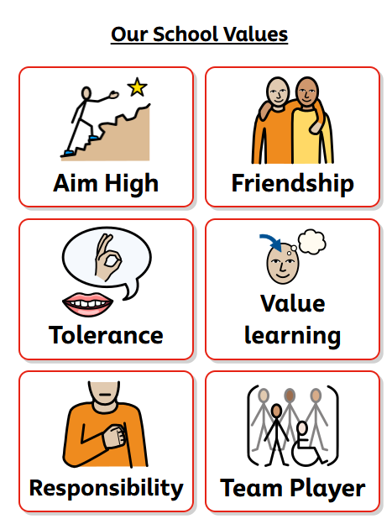

Appendix 2:
Fundamentals of British Citizenship

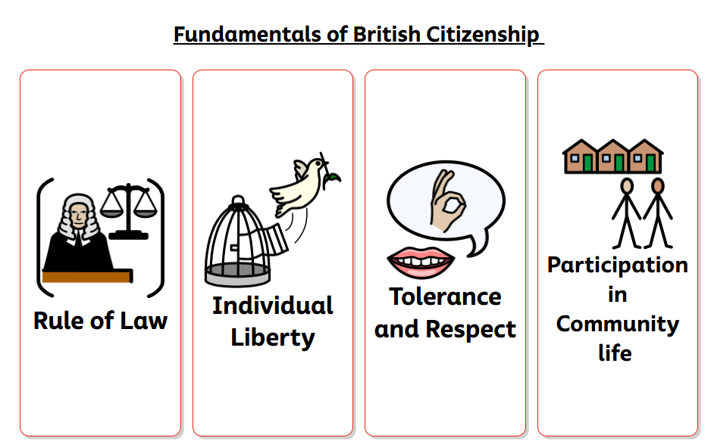

Appendix 3
We keep safe

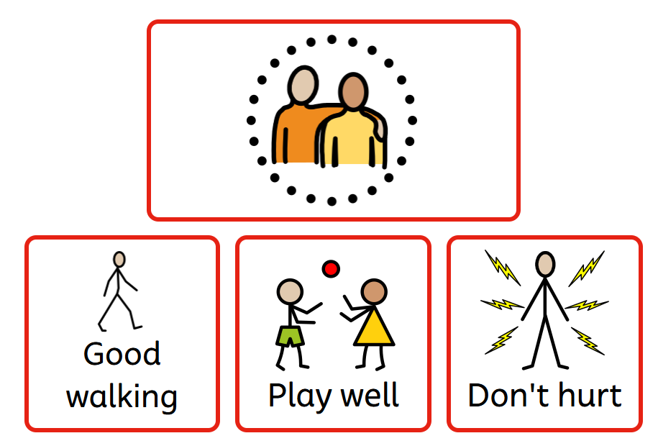

Appendix 4:
We are ready to learn (KS1)
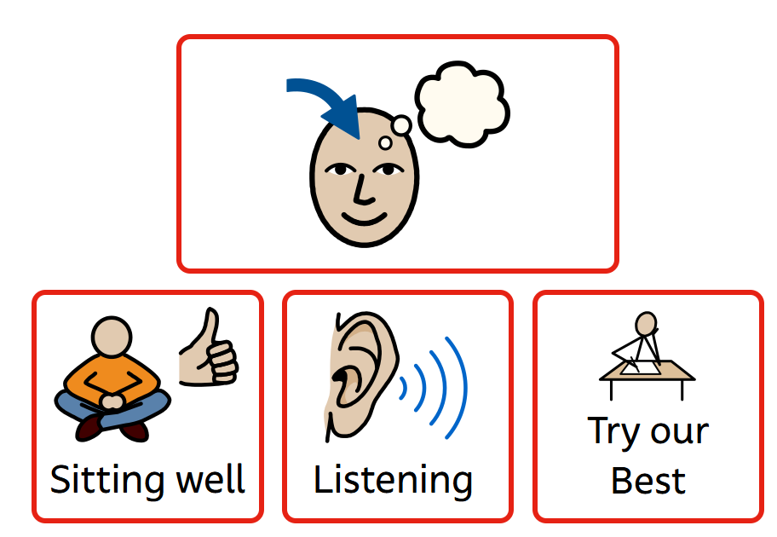

We are ready to learn (KS2)

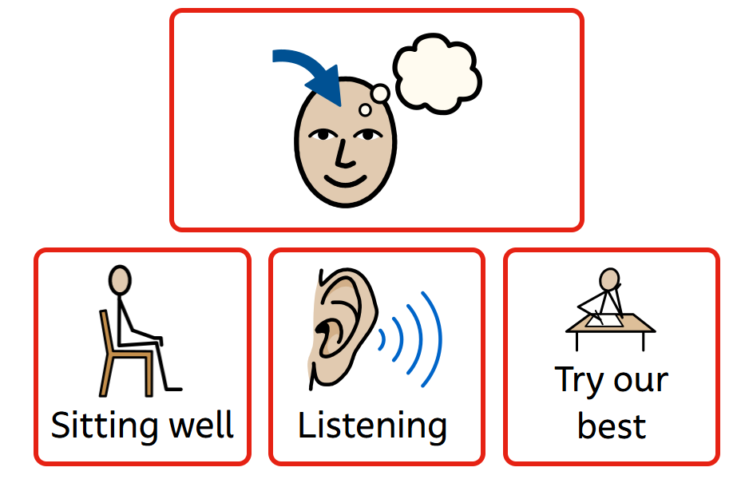

Appendix 5:
We respect everyone and everything

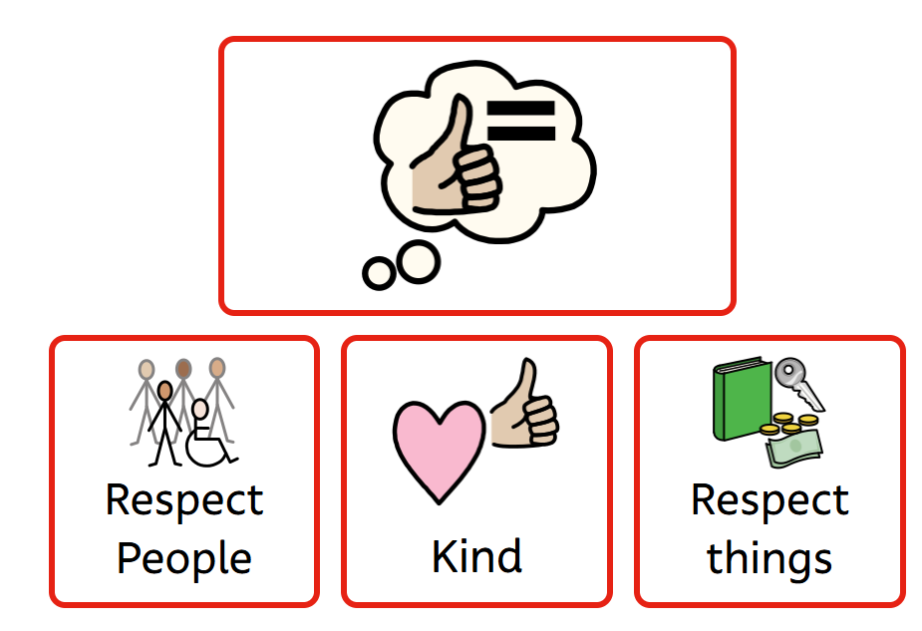

Appendix 6:
We Be the Best We Can Be

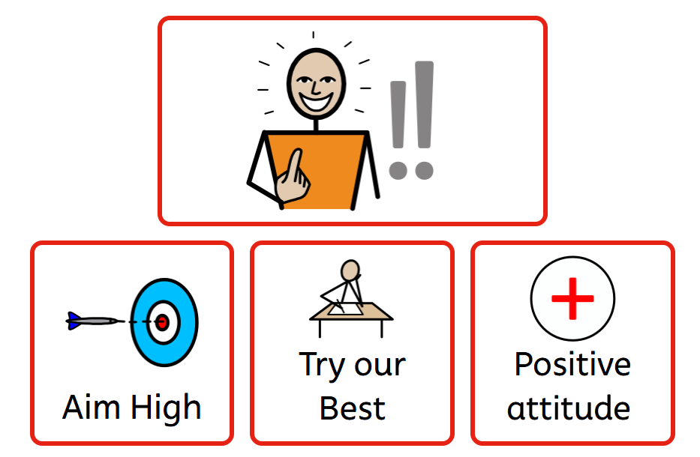

Appendix 7: (Guidance for Staff)

Types of Boundaries
Type | Method | Previously
Low- Level Boundary (Reminder) | X put the pencil down  Sarah lets listen now please | Stop messing with the pencil  Stop shouting out
Limitation Boundary | Removal of a resource or a toy with the intention to try again | I am taking that and you will not be allowed it back
Responsibility Boundary | Putting right what they have destroyed / ruined caused | Rarely made to clear up – make amends

Appendix 8 (Guidance for Staff)

Connection and regulation procedure:

Step 1 | Therapeutic response given NAME  FEELING BEHAVIOR  ENCOURGE | Respond therapeutically with connection, empathy and insight into the brain. This will help shift a child’s overwhelmed reptilian brain into rational brain which will help them think and  reflect.
Step 2 | Offer a BOUNDARY (either a limitation or a responsibility)  Offer a TEACH statement (If ready to hear this) | Create opportunities to take responsibility for their actions and learn through setting boundaries.
Step 3 | Calm time Or Thinking time (OR  both) | Re-define ‘punishment’ and create the opportunity to self- regulate and reflect instead.
Step 4 | Ongoing | Create trust, reliability and security through consistency.

An Example script:

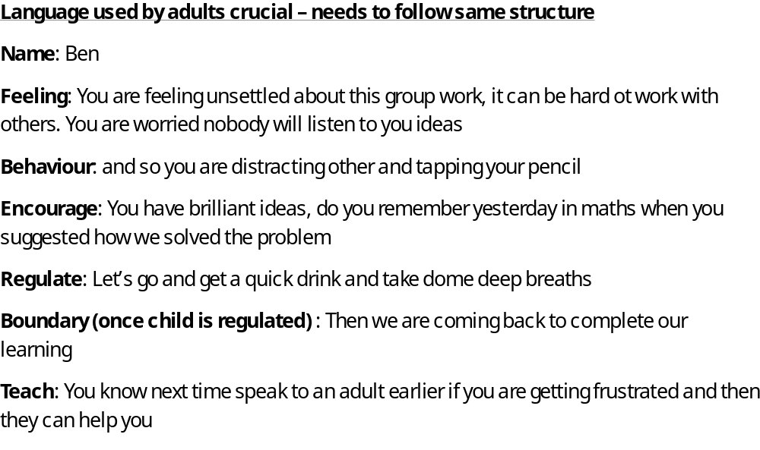

Appendix 8:
Written statement of relationship principles:

- Every child understands they have the right to feel safe, valued and respected, and
- learn free from the disruption of others
- All Children, staff and visitors are free from any form of discrimination
- Staff and volunteers set an excellent example to the Children at all times
- Recognition, motivators and support strategies are used consistently by staff, in line with the behaviour for learning policy
- The Behaviours for Learning policy is understood by all Children and all staff
- The exclusions and suspensions policy explains that exclusions will only be used as a last resort, and outlines the processes involved in permanent and temporary
- exclusions
- Children are encouraged and supported to take responsibility for their actions
- Families are involved in behaviour incidents to foster good relationships between the
- school and child’s home life

The Governing Board also emphasises that violence or threatening behaviour will not be tolerated in any circumstances.

